

Name: Kannuru Hykulu

Roll no: 226W1A6120

**Linux ISO Image Using VMWARE**

**Tools:**

1.vmware machine that

2.redhat

**Step1:**

We have to run the vmware machine and we want create an new machine which we had download the redhat we want to add in the vmware machine**.** Here we adding the redhat file and in default it will be install which we had given names of users after clicking the next the redhat will be install in VMware machine.

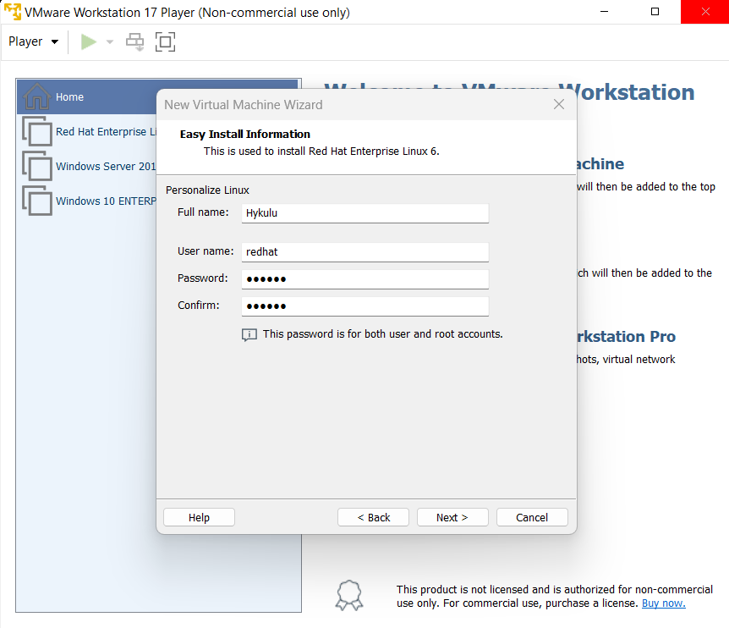

**Step 2:**

Here we have to arrange the disk size uoto:25.0

And select the store virtual disk as a single file

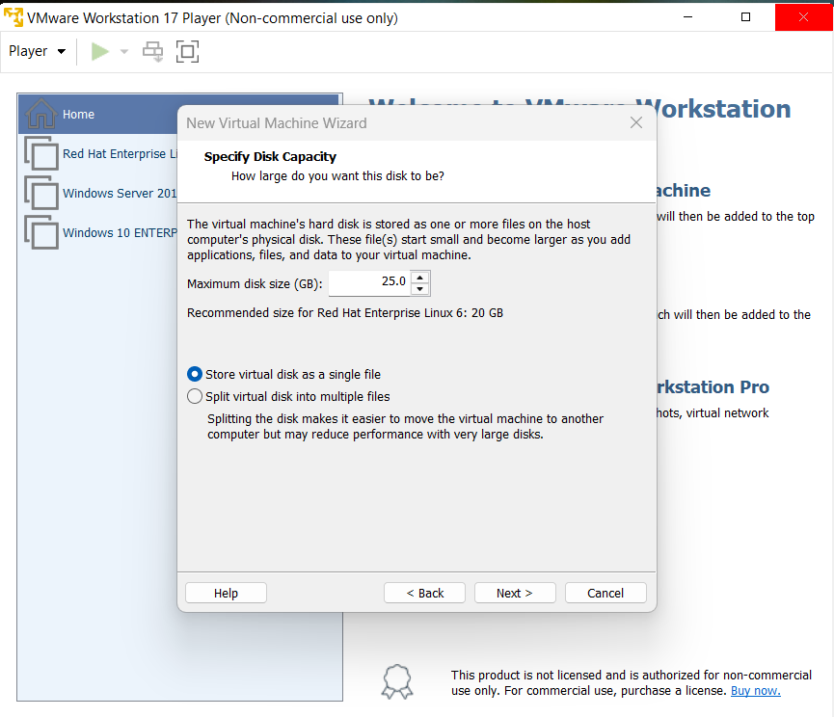

**Step 3:**

And the file of redhat will be updated and we get

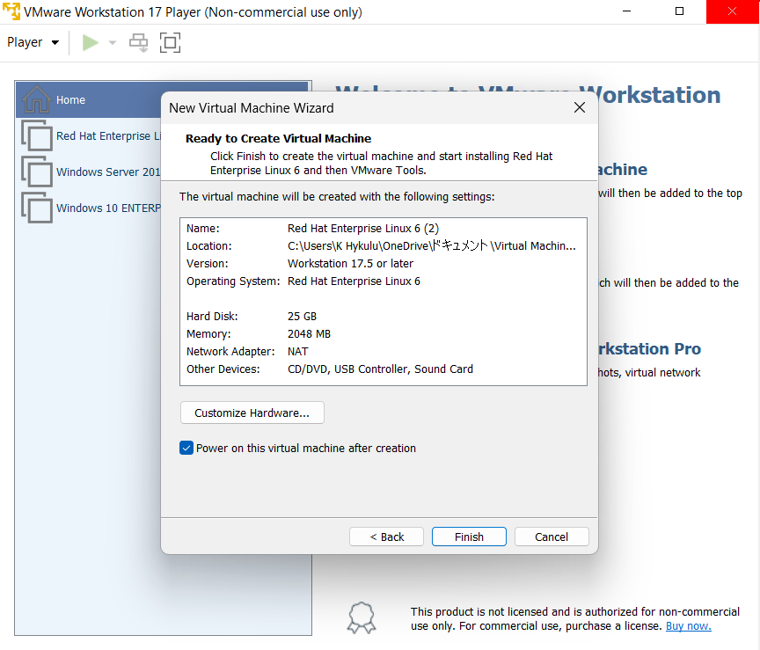

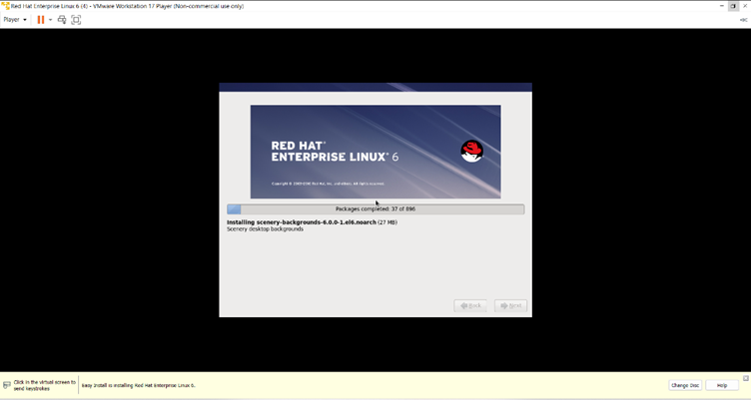

**Step4:**

Here the user which we create in the vmware is available here

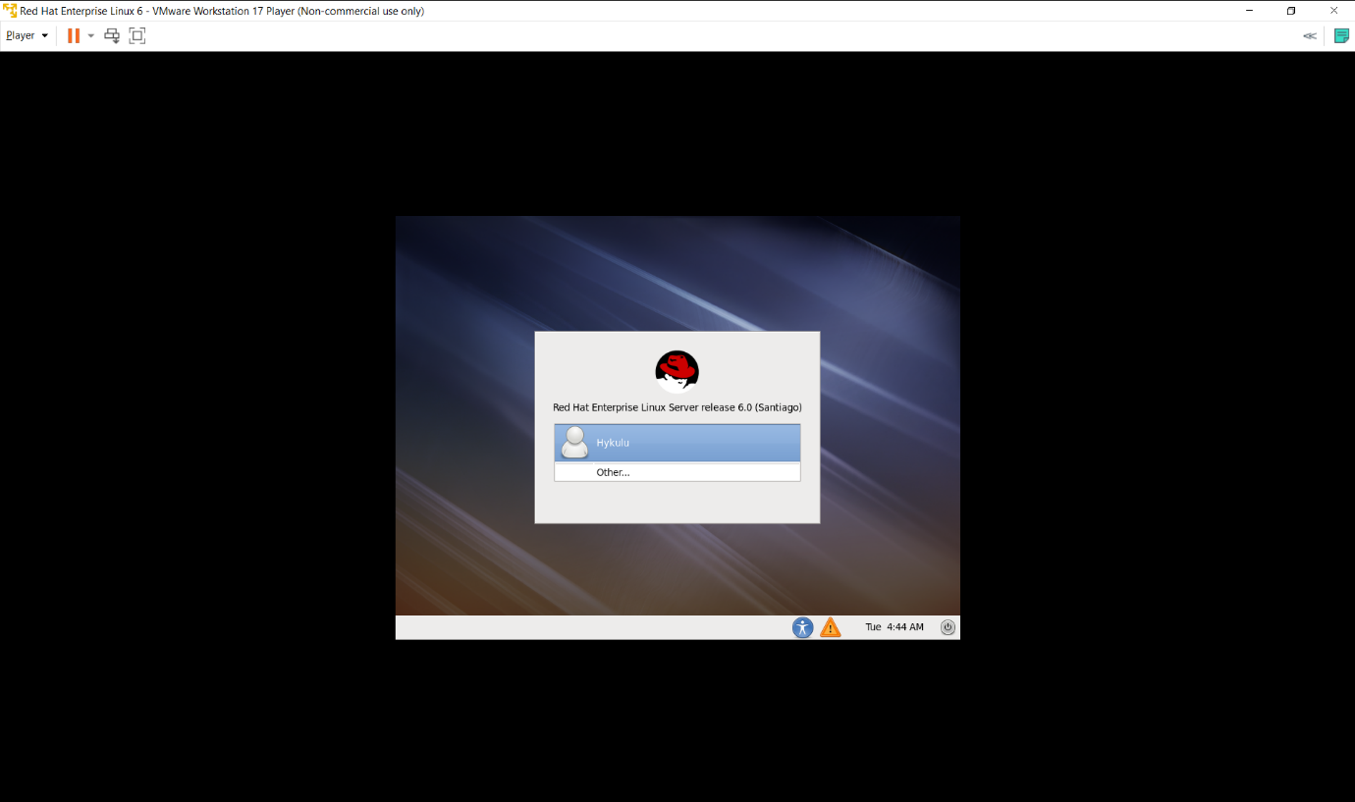

**Step5:**

we have to click the other there we want to give the

Username: redhat

Password: redhat

Open the terminal and give the commands

Su –

Password as: kulu

useradd navya

userpasswd navya

new password: kulu6

retype password: kulu6

tail /etc/passwd

Init 6

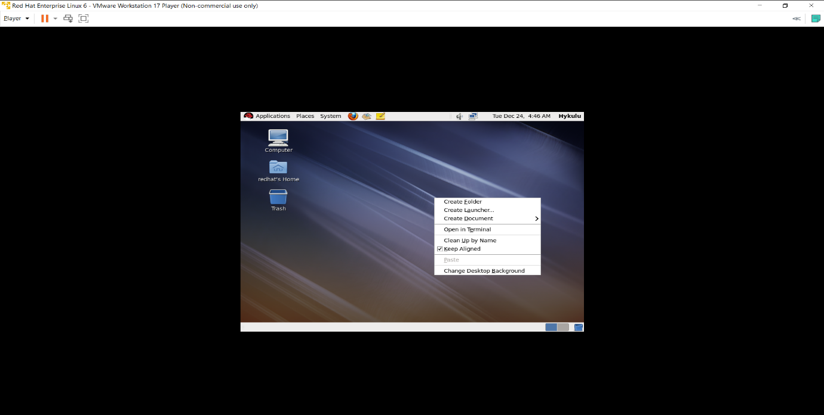

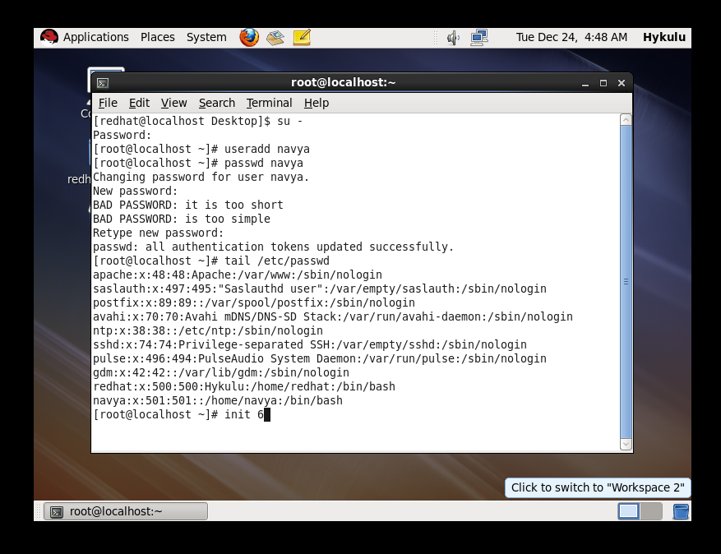

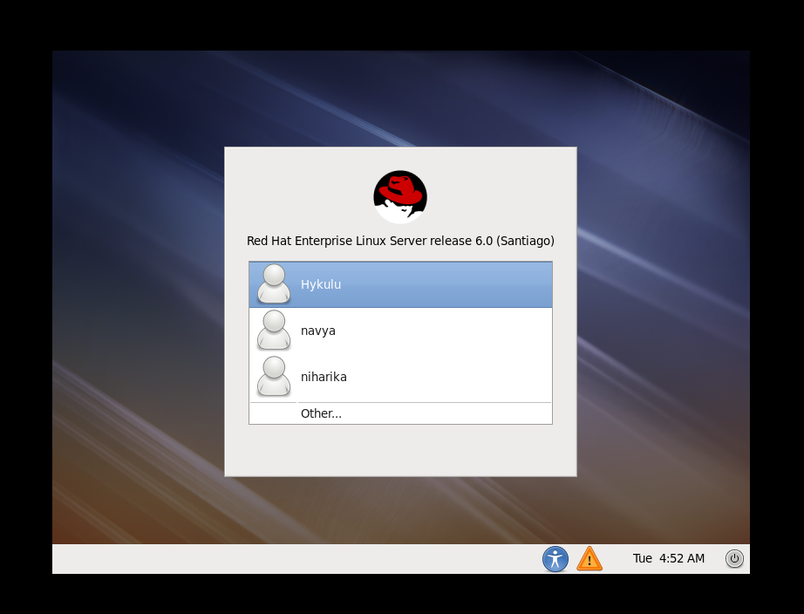

**STEP 5:**

Now we are use to lock the user for that we use commands

First open the other and give the

username: root

password: kulu

The give command:

usermod -L navya

tail /etc/shadow

init 6

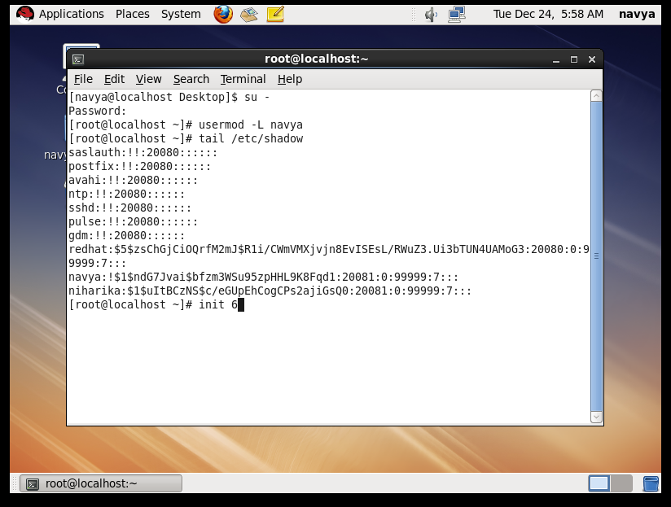

**Step 6: After lock the user we get authentication fail when login in our user with password to reset we use the command**

**usermod -U navya**

**tail /etc/shadow**

**init 6**

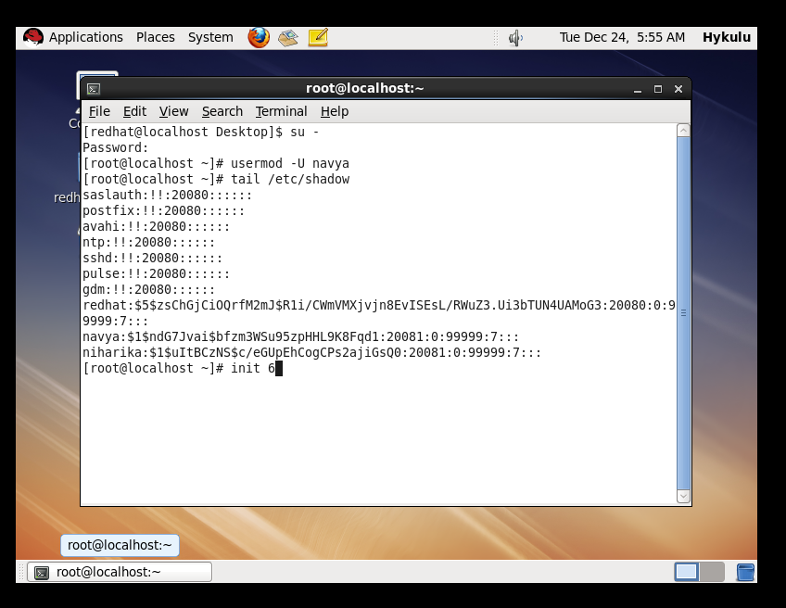**Here we can easily login into our user**

**Step7:**

**I want delete the user for that the command are**

**Userdel navya**

**Tail /etc/passwd**

**Init 6**

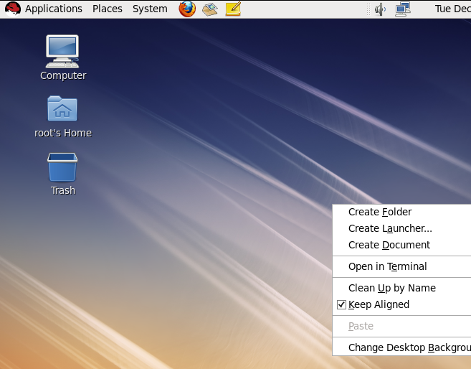

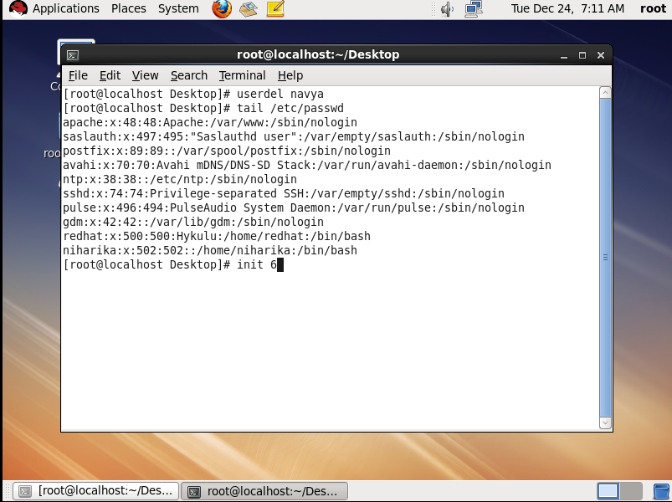

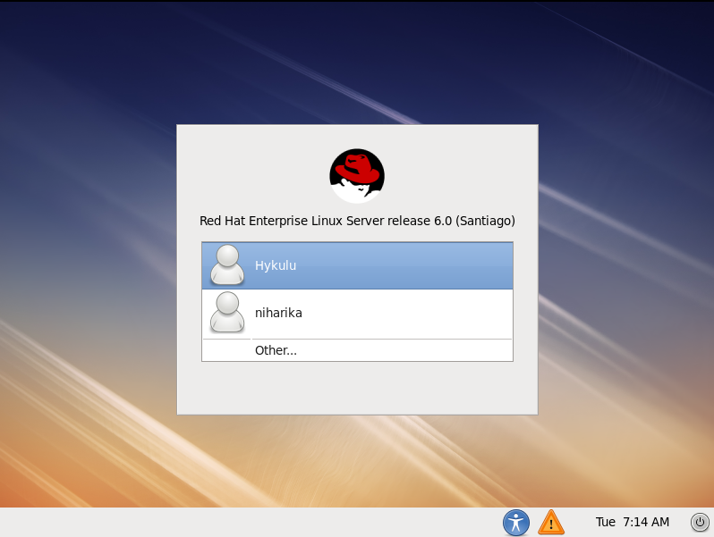

Now we are creating number of ucers in the same way and grouping all those with certain department

Step 1:

We have to login in the user and open the terminal give the commands.

groupadd hr

groupadd teaching

groupadd class

tail /etc/group

tail /etc/passwd

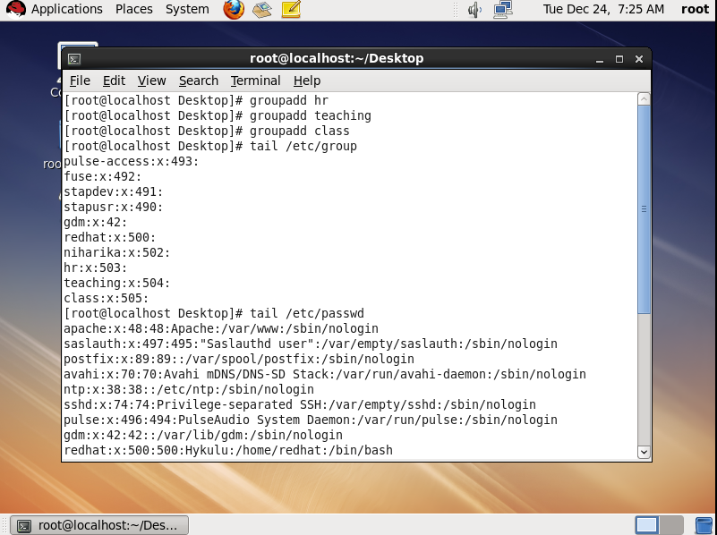

Step2: we want assign the groups of certain department to the certain users as:

usermod -G hr redhat

usermod -G teaching Niharika

tail /etc/group

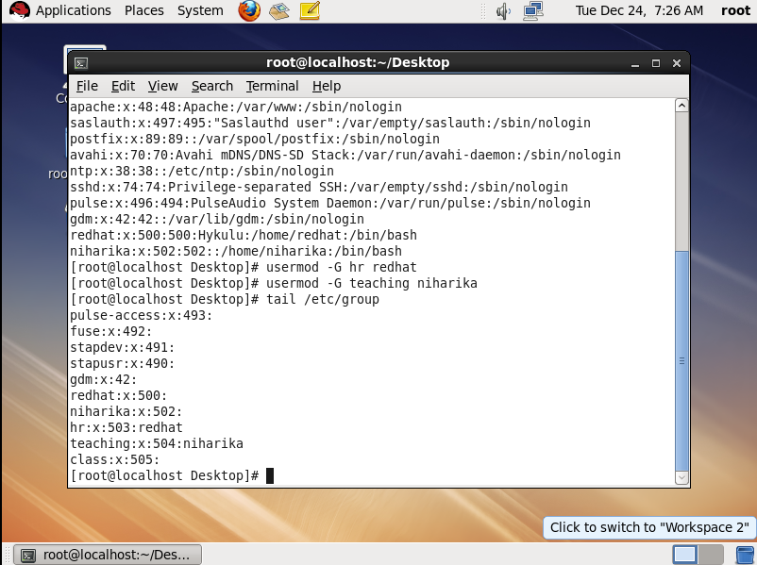

**FILE DIRECTORY**

Now we are creating folders and creating a file in that and adding text in it and

locking the file and unlocking it as:

**STEP1:**

1.locking the file

Now we want login in the user and open the terminal give the commands as

Ls

Mkdir kaja

Ls

Cd kaja

Vi hyku

Cat hyku

Chmod 000 hyku

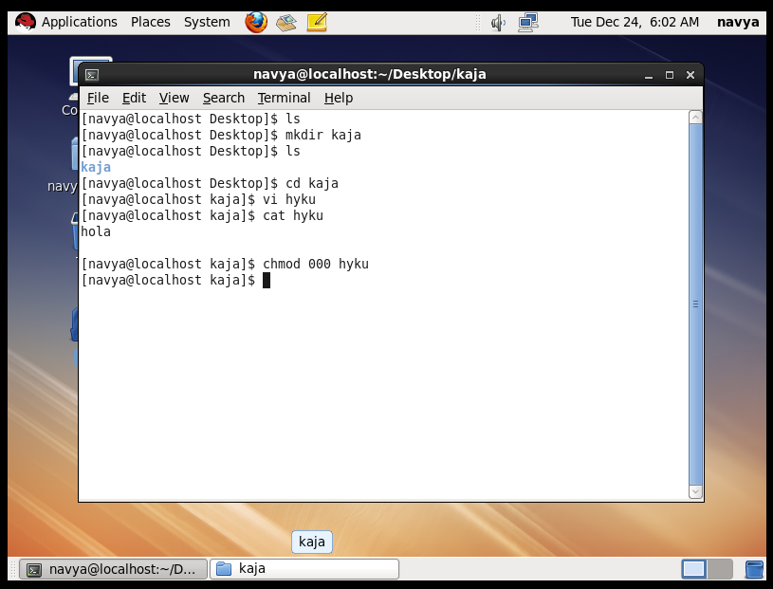

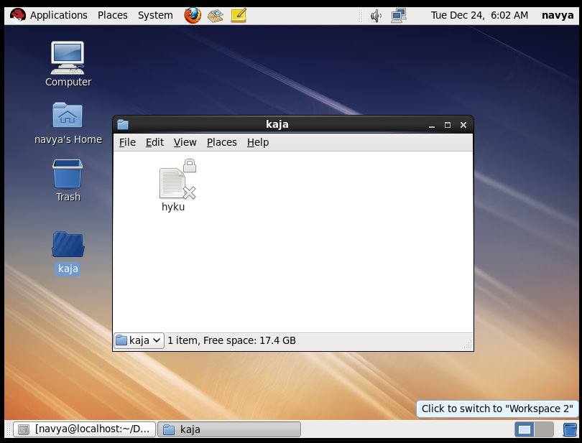

2.unlock the file

Now we want login in the user and open the terminal give the commands as

Ls

Mkdir kaja

Ls

Cd kaja

Vi hyku

Cat hyku

Chmod 000 hyku

Chmod 700 hyku

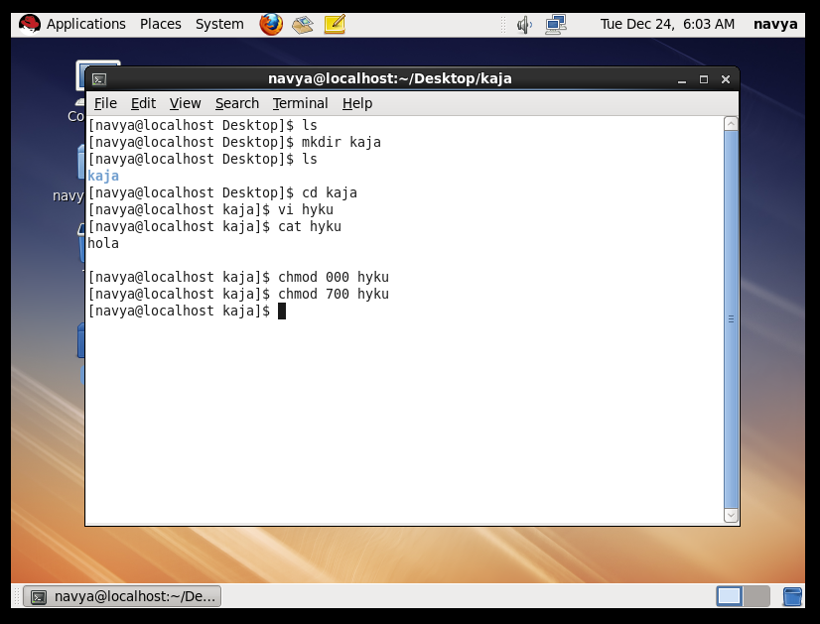

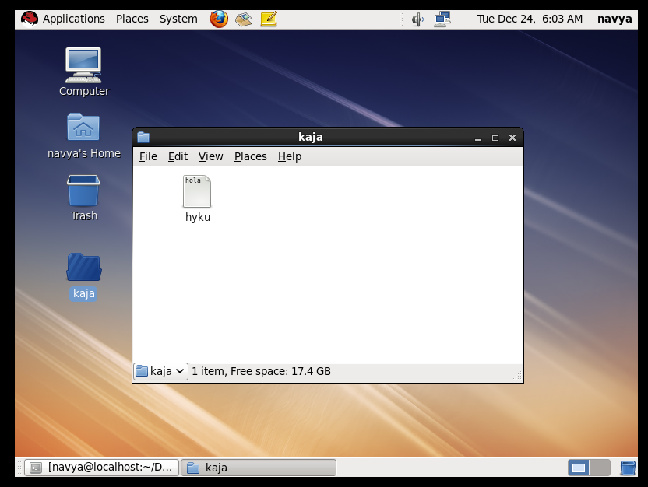

USER MAGEMENT

We are knowing the user management of passwords of pervious by using these commands

Chage -l redhat

Chage -m 30 redhat

Chage -l redhat

Chage -M 90 redhat

Chage -l redhat

Chage -W 3 redhat

Chage -l redhat

